Step 1: Construct Platform Frame

Parts needed:

MEASUREMENT Hex Key

MEASUREMENT Wrench

6x MEASUREMENT Screws

6x MEASUREMENT Nuts

2x MEASUREMENT L-Beams

2x MEASUREMENT C-Beams

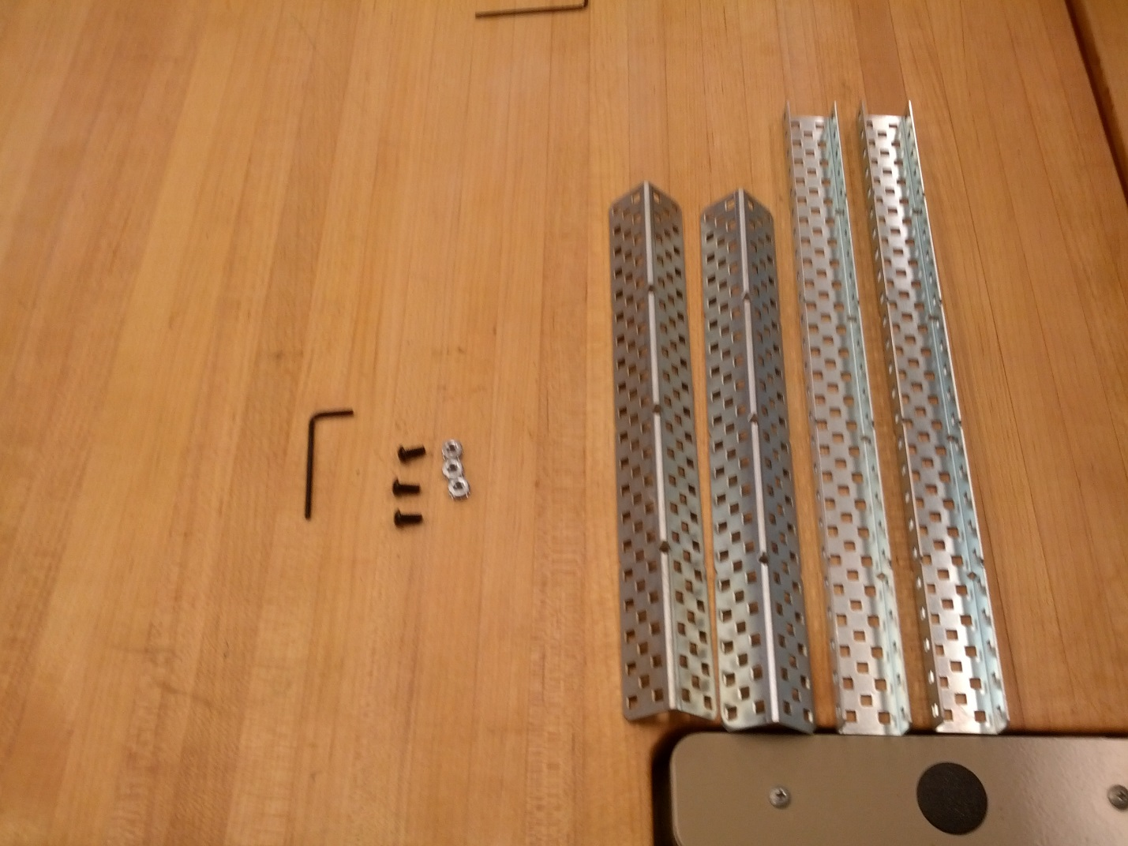

1. Assemble First “L” using two screws

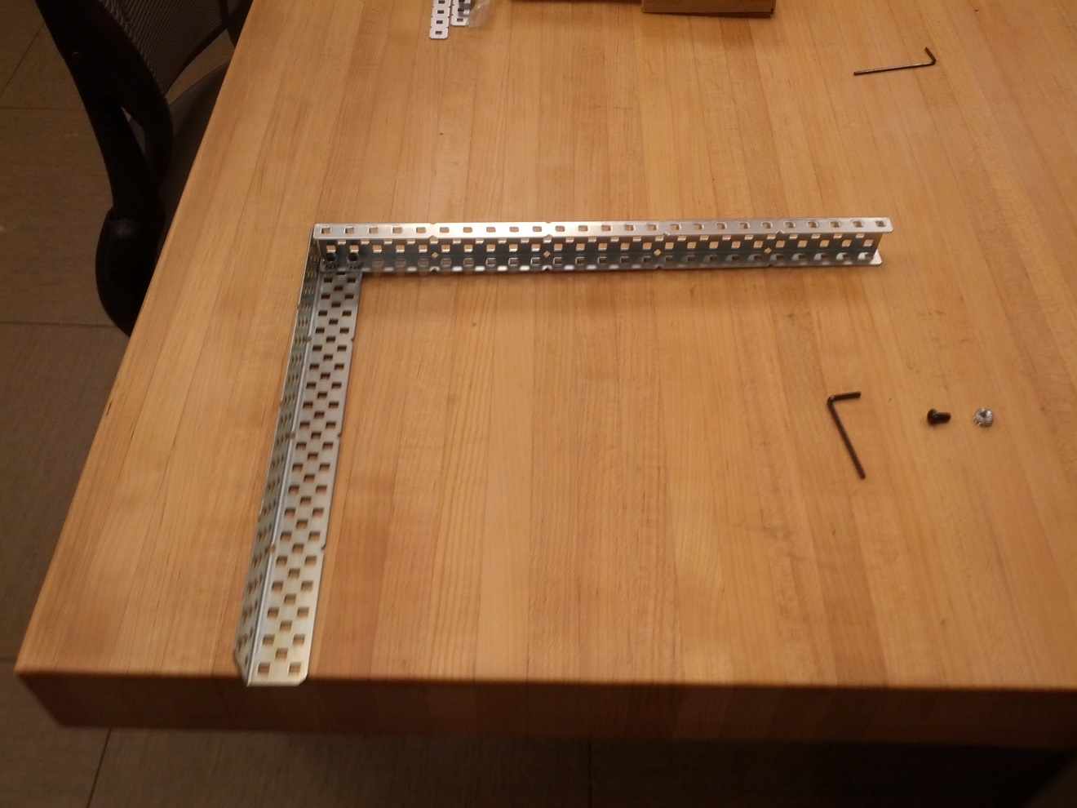

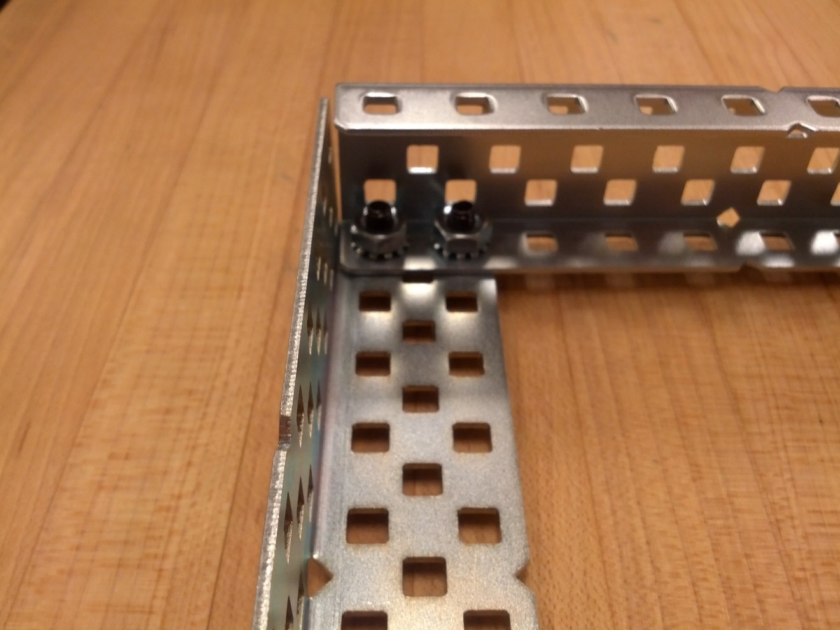

1. Assemble second “L” using 1 screw

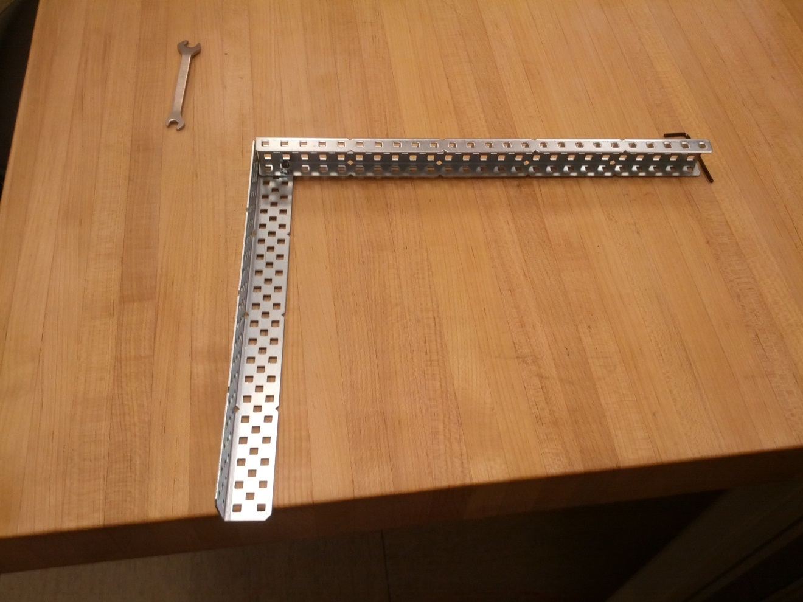

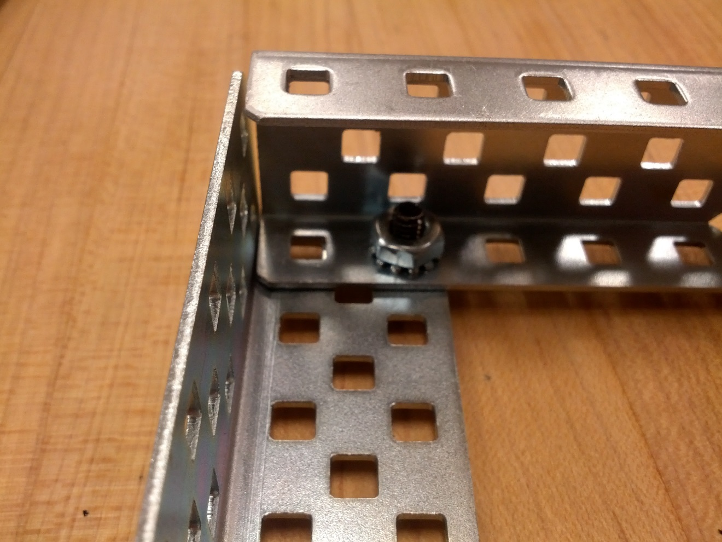

NB: Ensure that both “L’s” have same “handedness”

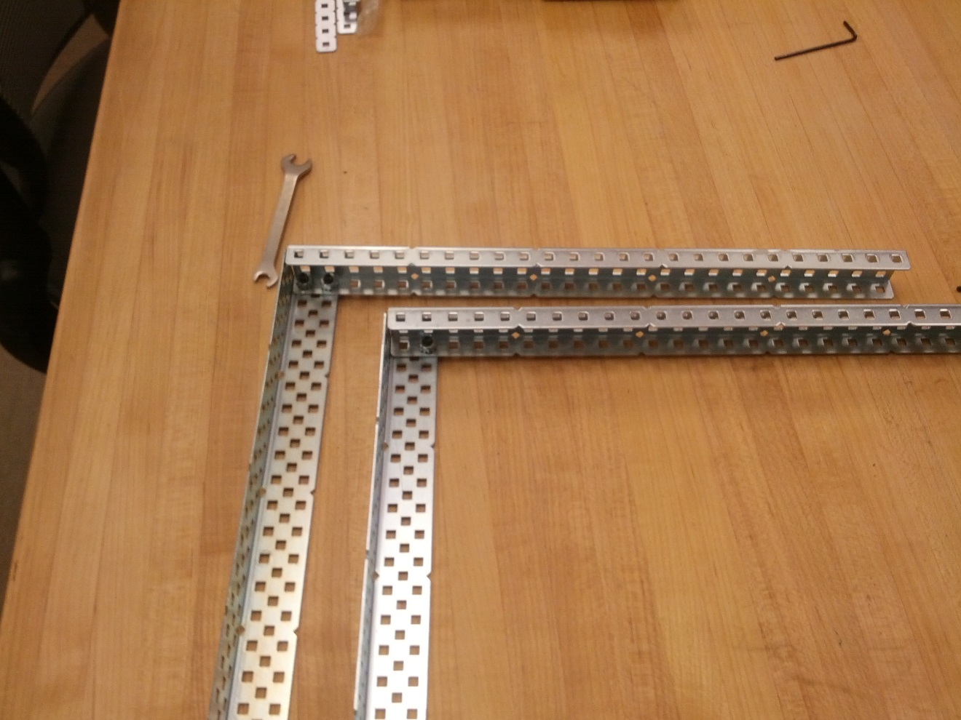

1. Join both “L’s” to form frame. Use 1 screw to join in front, and 2 screws to join in back, as in parts a), b).

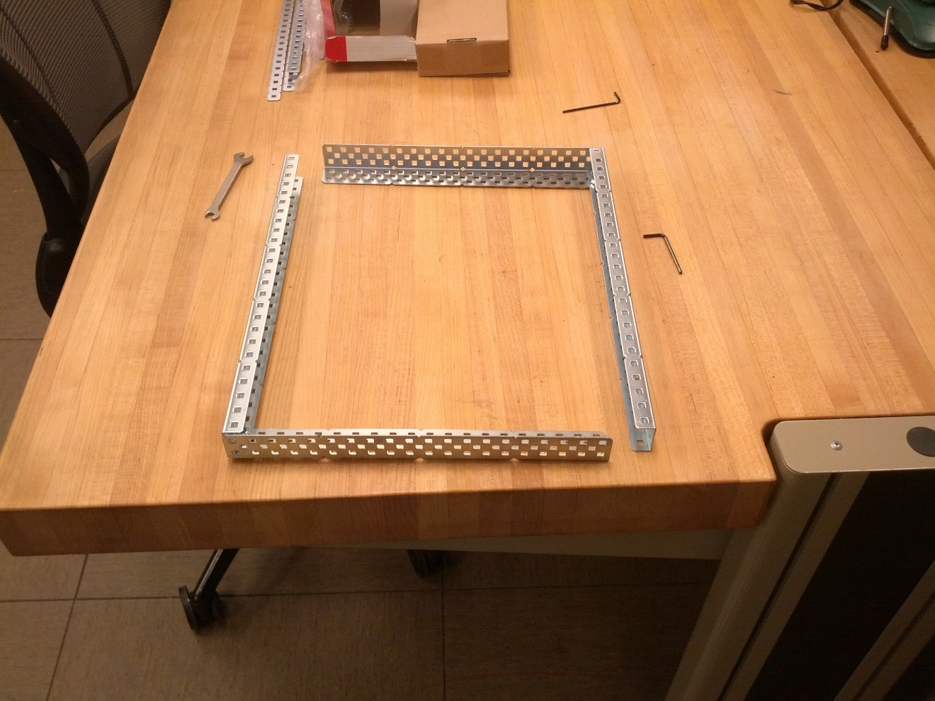

Step 2: Assemble the motors for the back wheels

Parts Needed:

MEASUREMENT THIN Hex Key

4x MEASUREMENT Screws

2x 3-Hole Rod Supports

2x Rod Cuffs

2x MEASUREMENT Rods

2x Motors

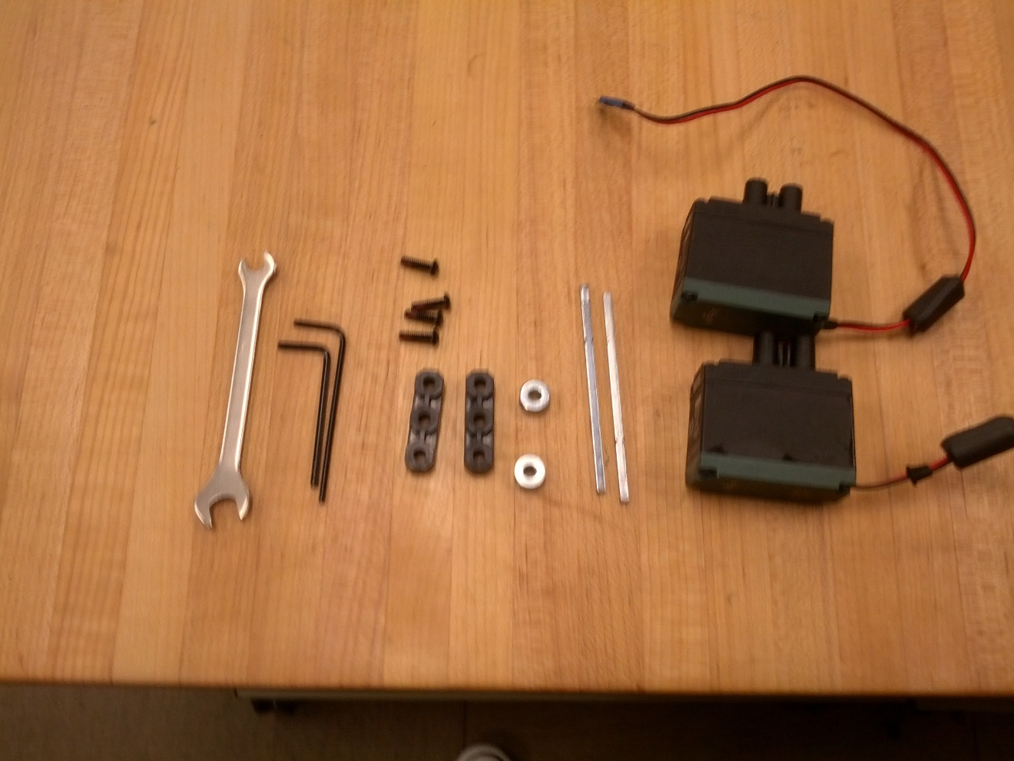

1. Thread rod through rearmost center hole in C-Beam, place cuff on inside of the frame

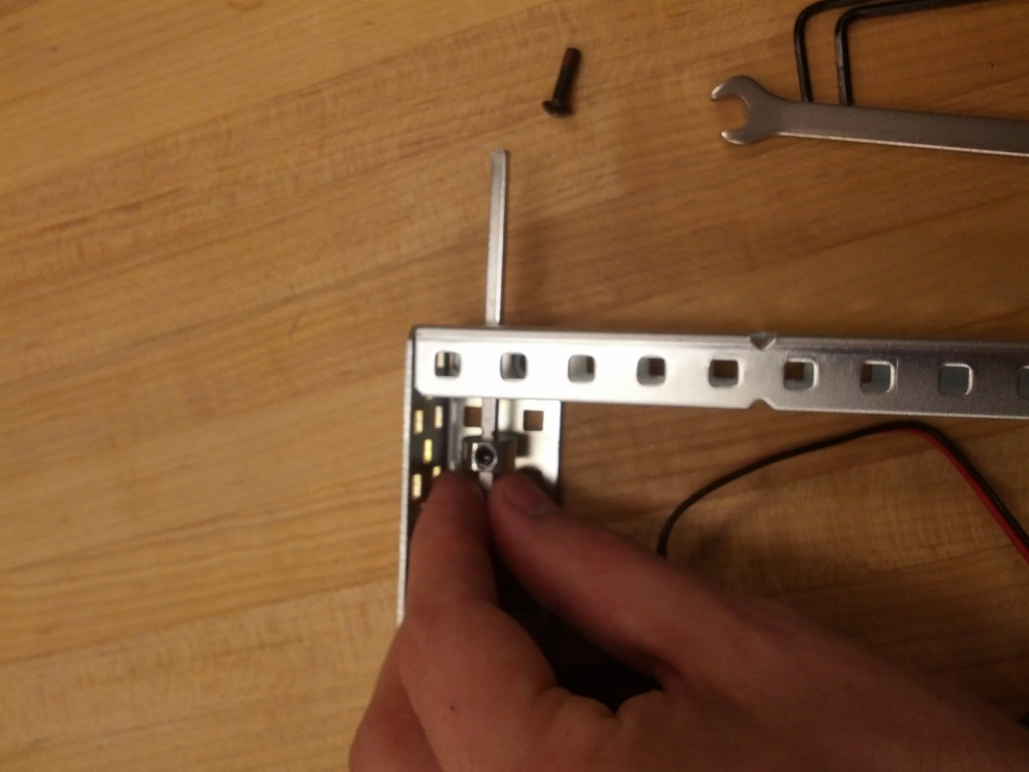

1. Match motor to back 3 holes in C-Beam, threading rod into motor hole

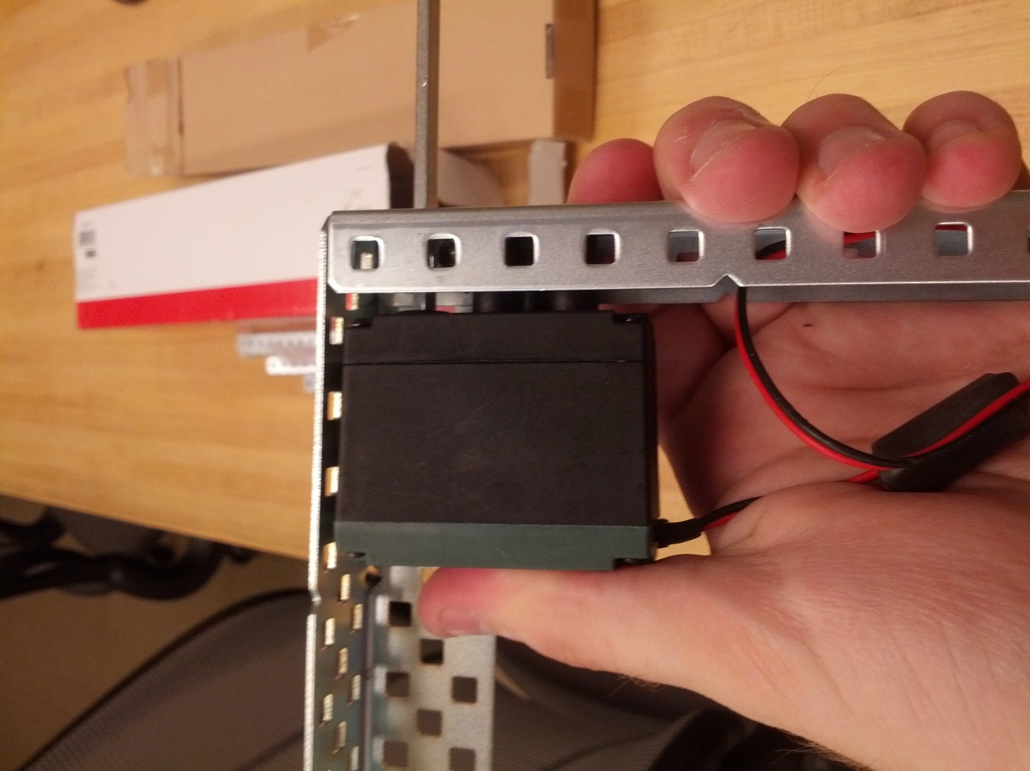

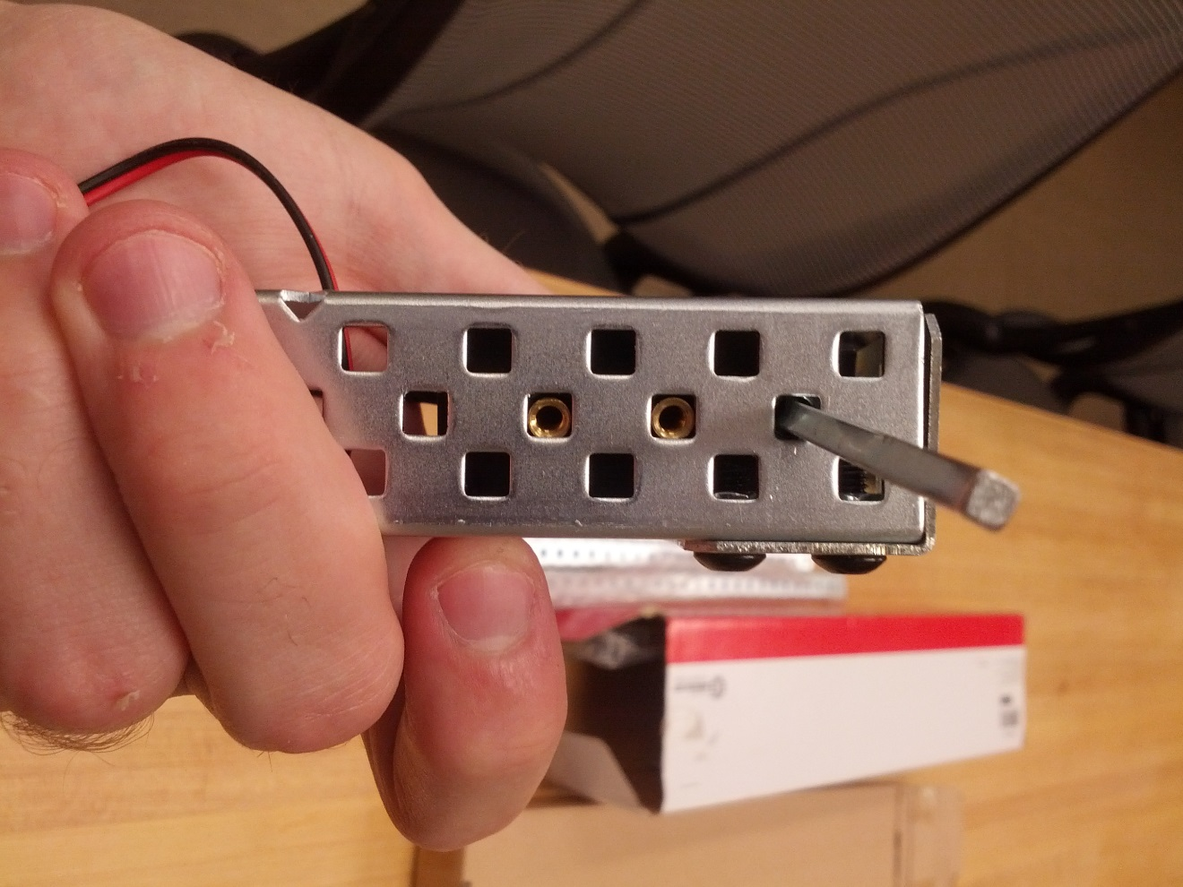

1. Attach rod bushing to motor with 2 screws

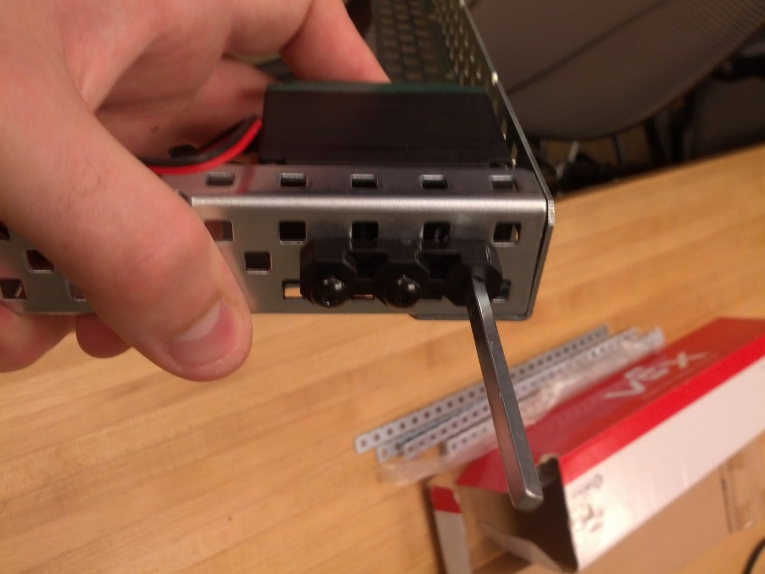

1. Repeat a)-c) for second motor

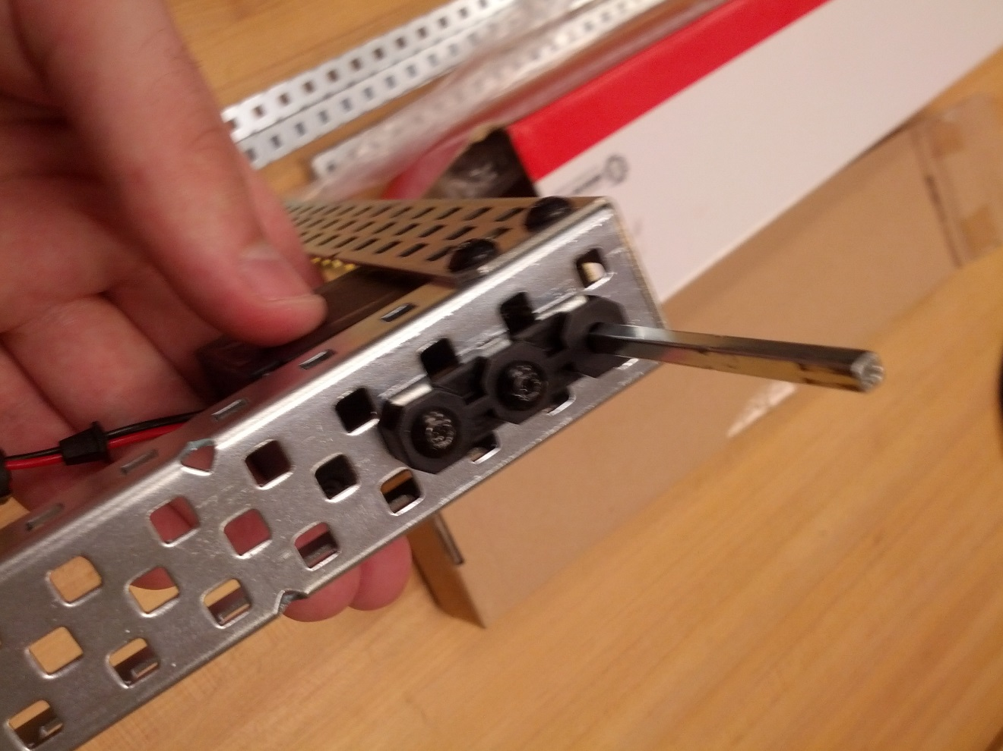

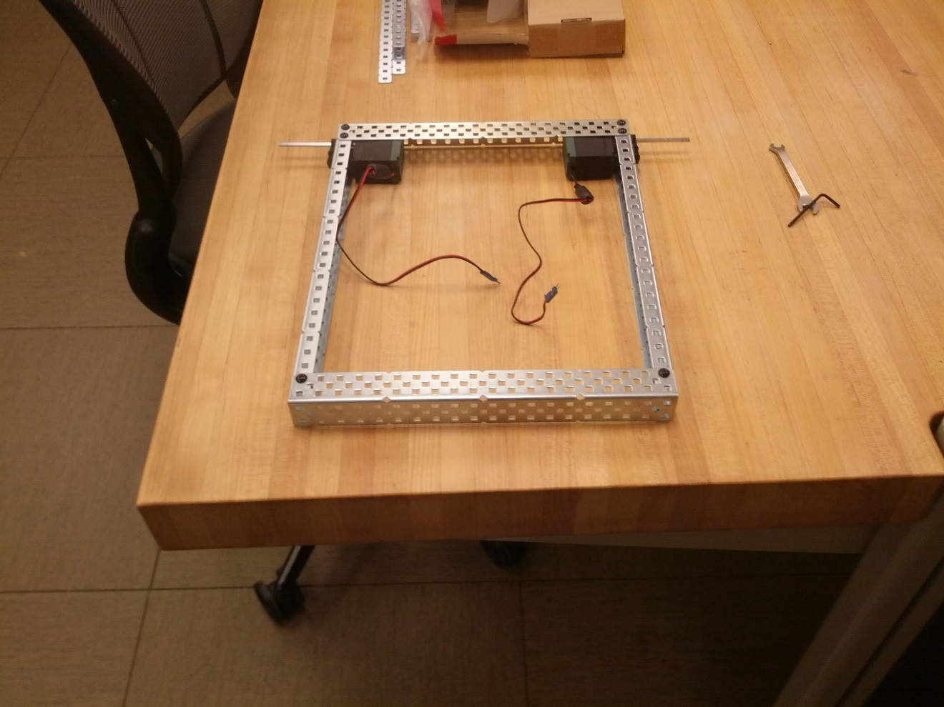

Step 3: Reinforcing the Frame

Parts Needed:

2x MEASUREMENT Bars

2x MEASUREMENT Plates

16x MEASUREMENT Screws

16x MEASUREMENT Nuts

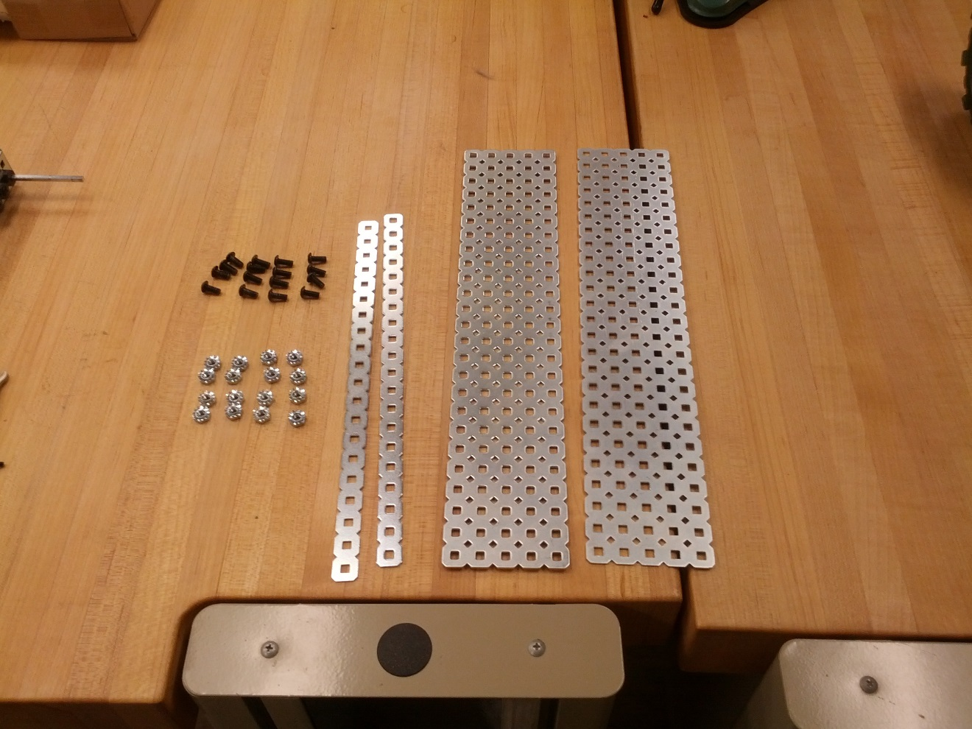

1. Attach bars to frame, leave 6 holes between bar and back of L-Beam, 7 holes between the bars

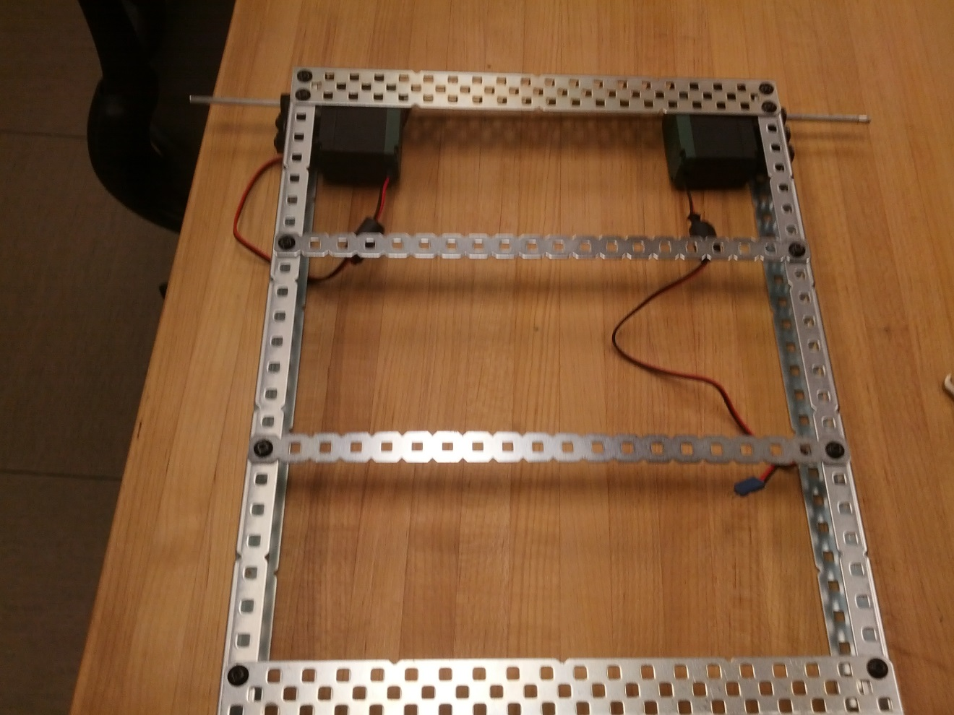

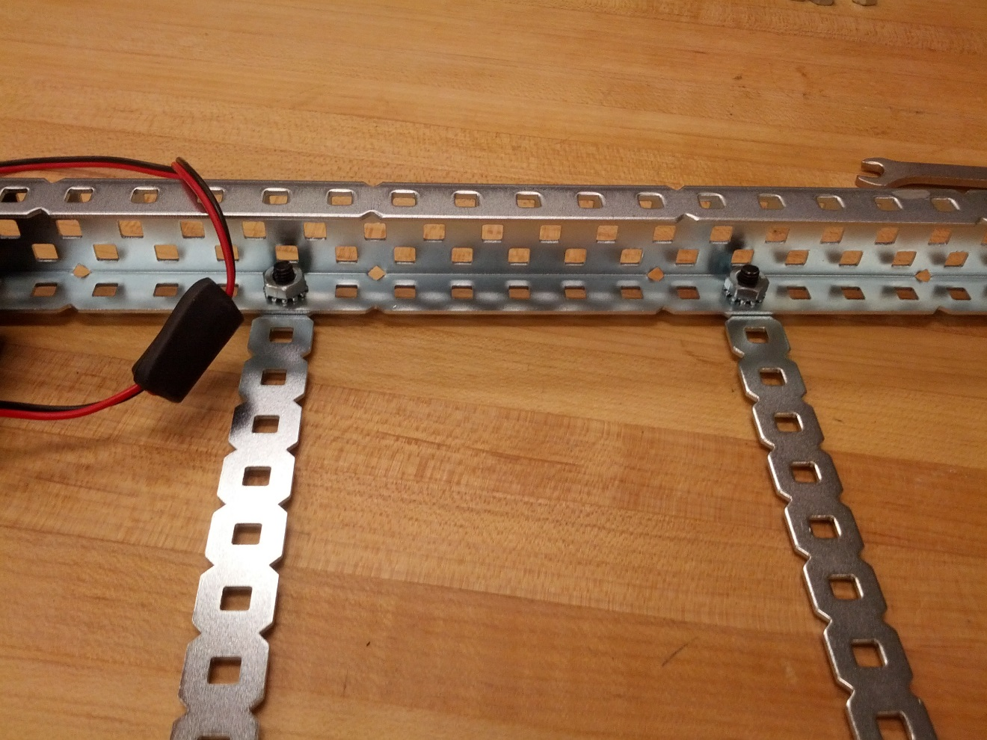

1. Attach plates to frame, using 2 screws for each L-Beam, 1 screw for each bar. Leave 3 holes between C-beam and plate, 2 holes between plates.

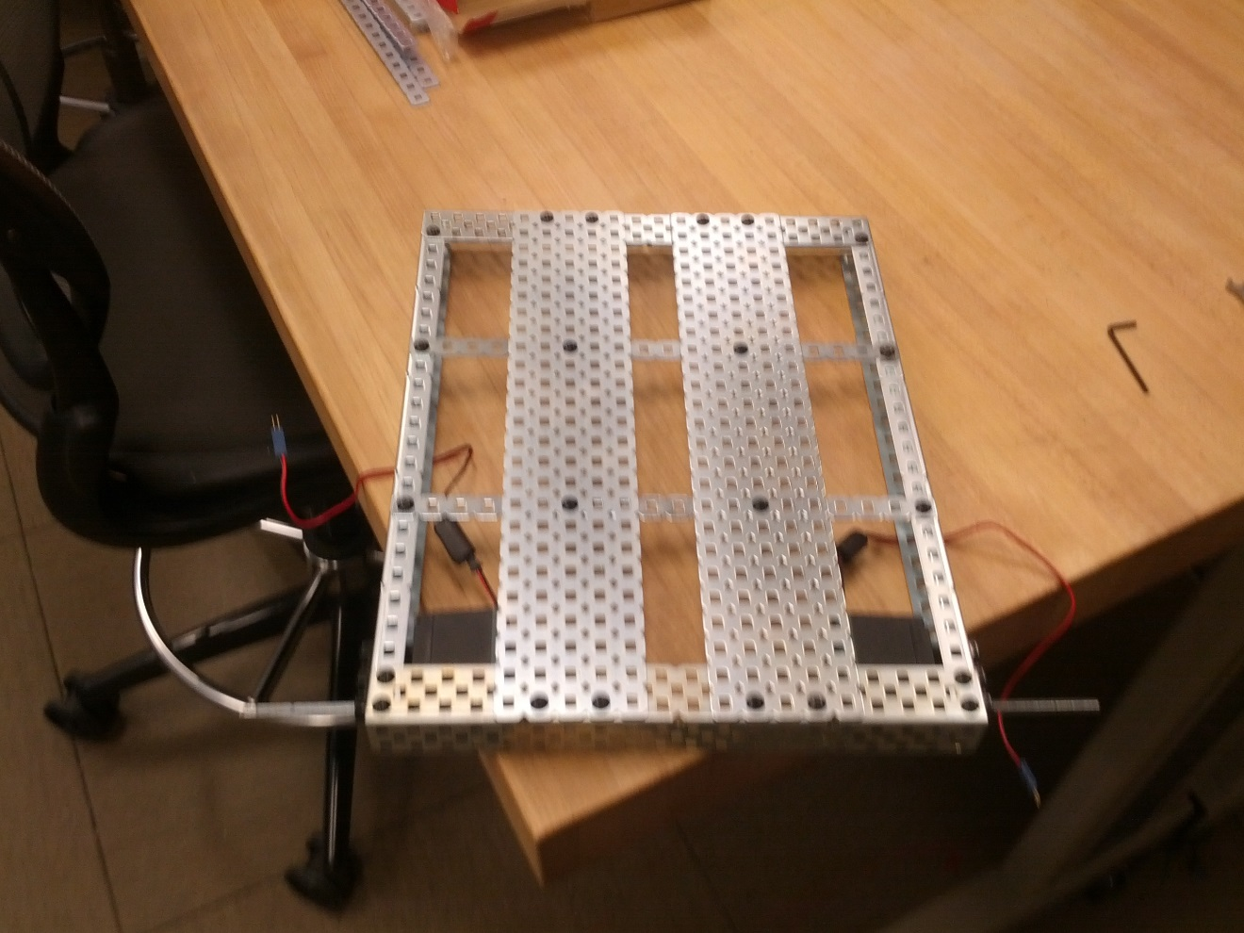

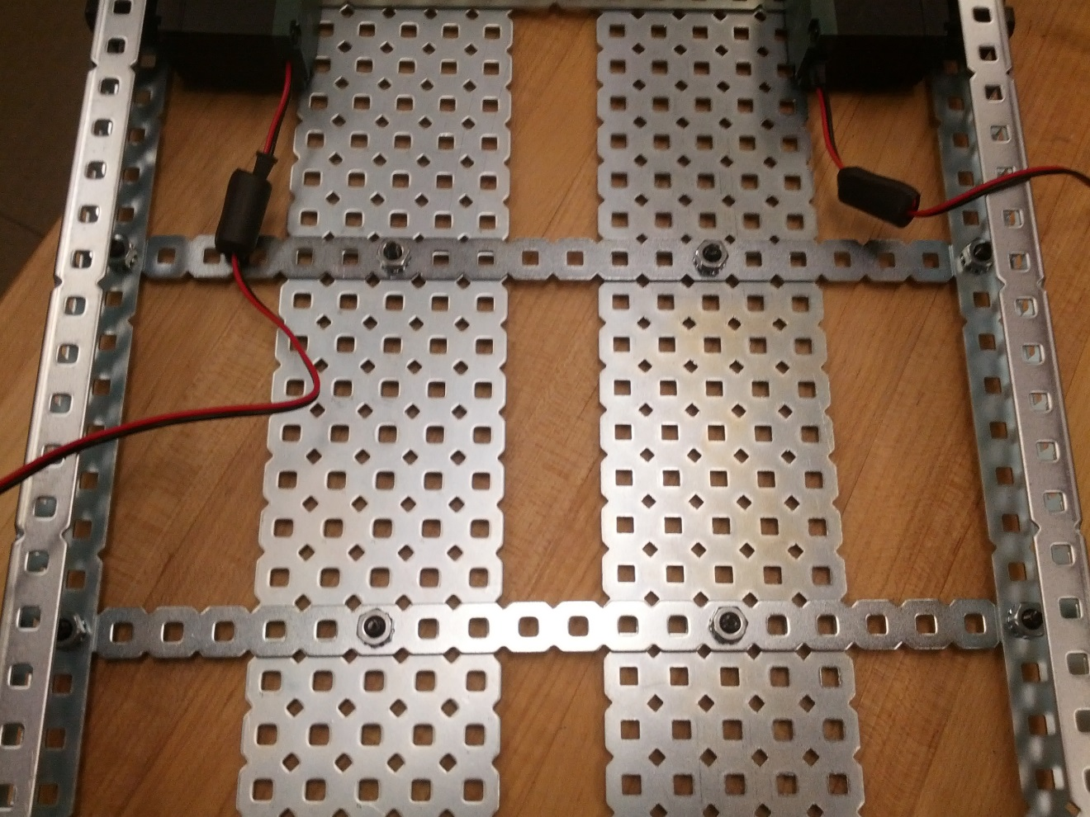

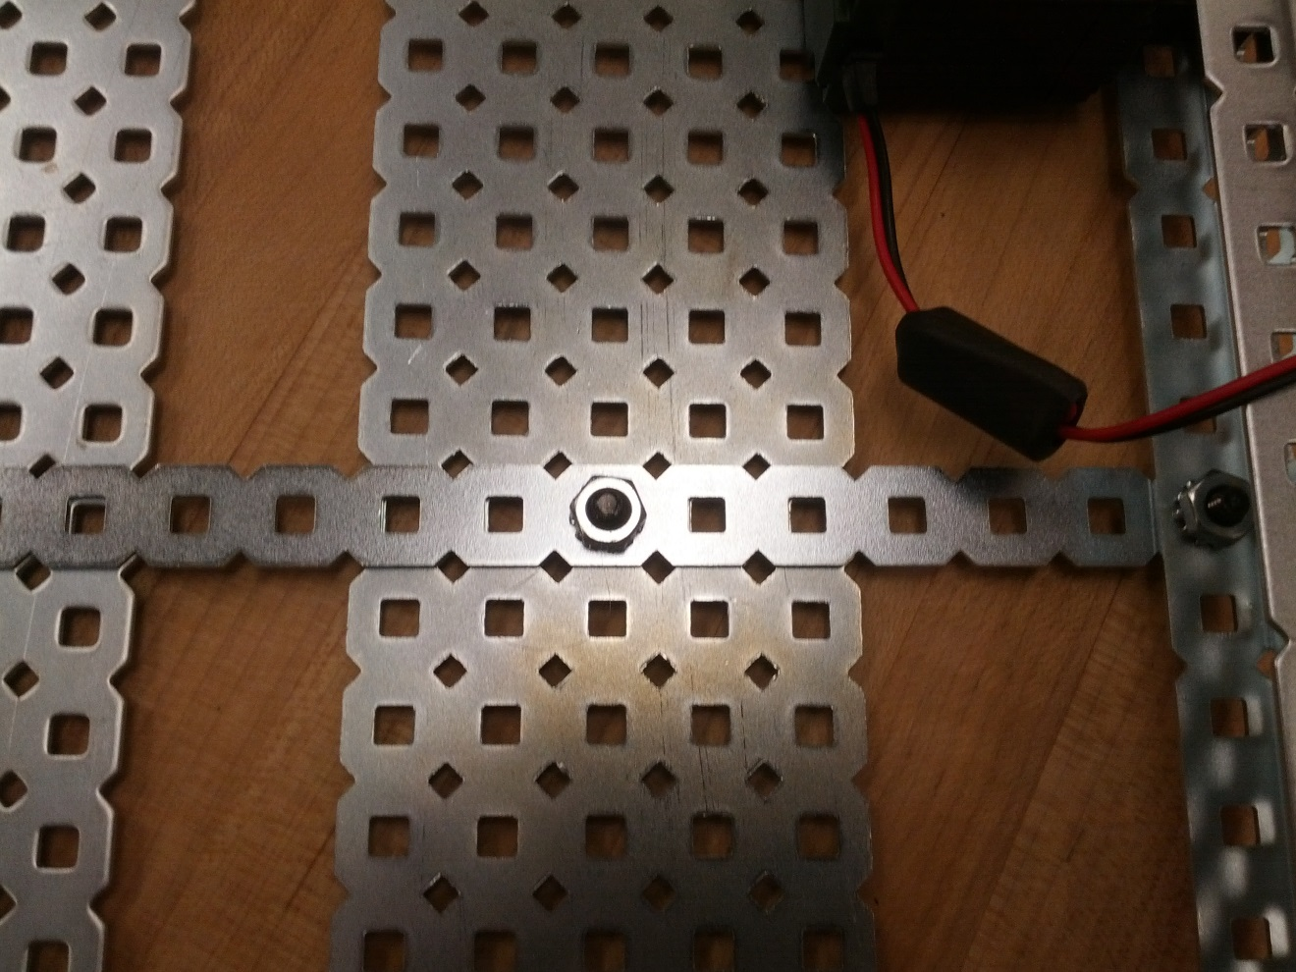

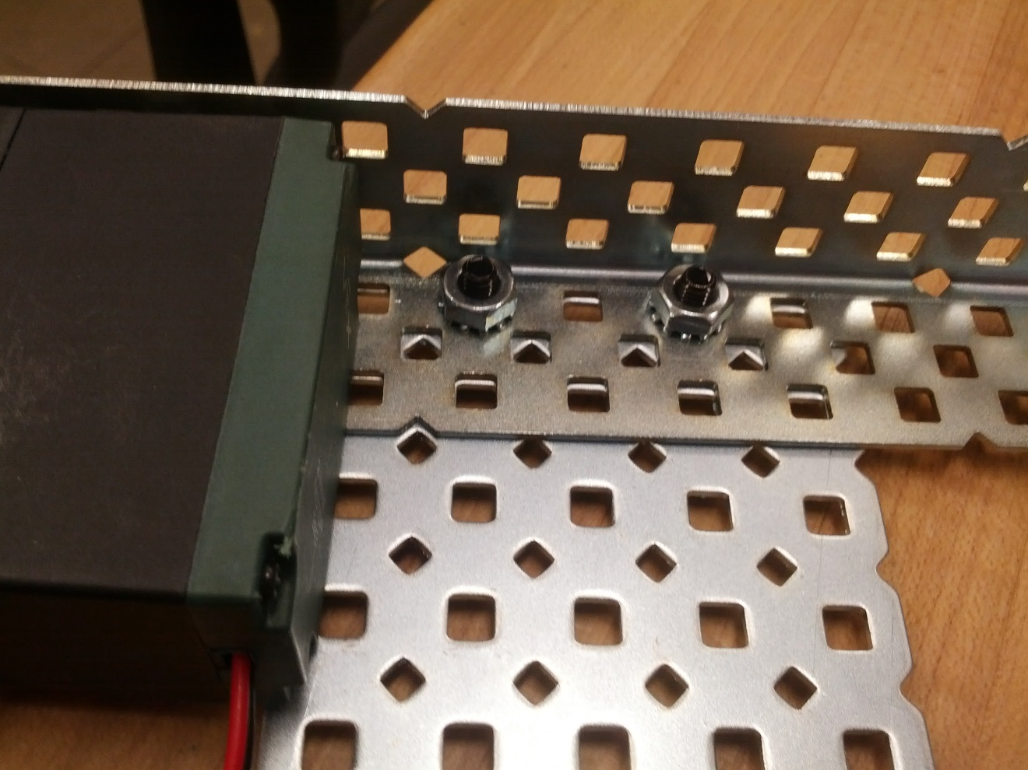

Step 4: Assemble Steering Rack Superstructure

Parts Needed:

2x LENGTH Rods

2x LENGTH Rods

4x Perpendicular axel attachments

12x Rod cuffs

LENGTH C Beam

(Picture of parts needed continued on next page)

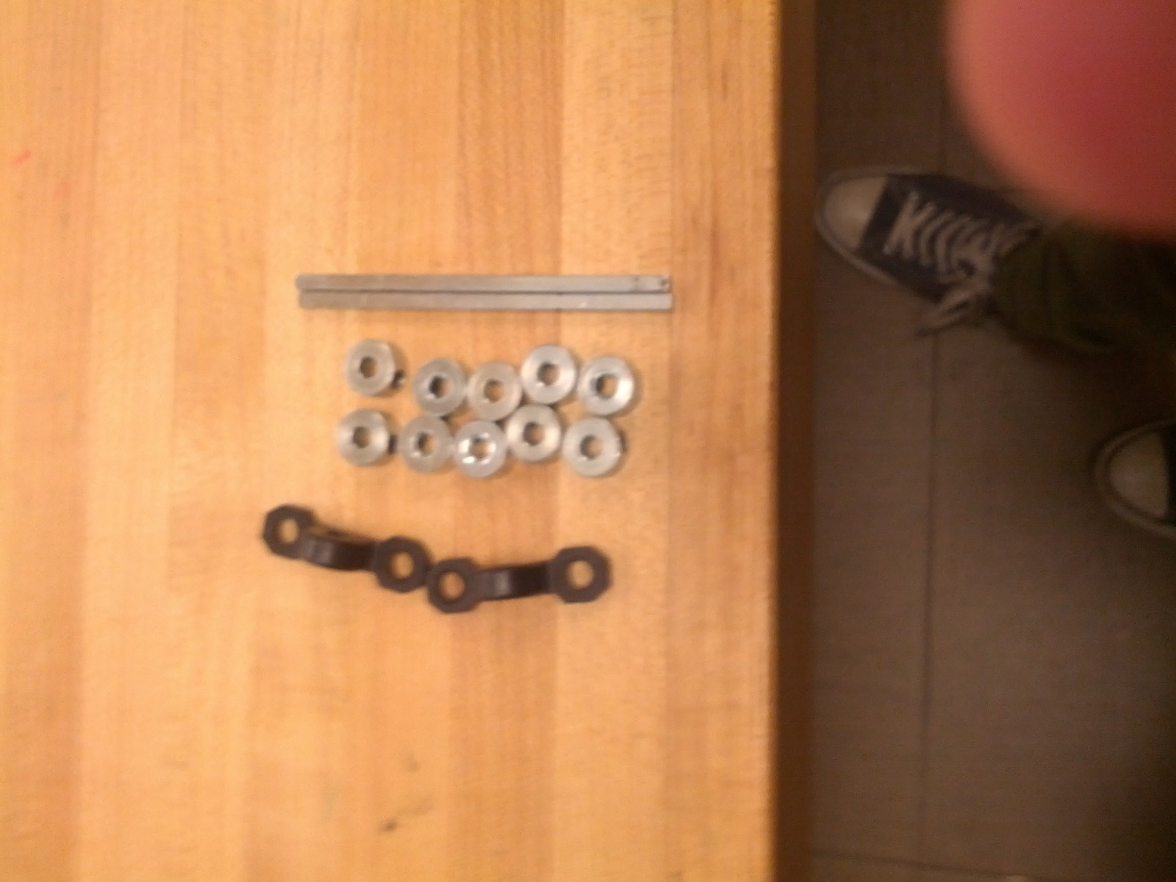

a) Insert rod through empty hole in corner of front of frame. Affix with cuff at top. NB: make cuff flush with top of rod, or have rod slightly deeper in cuff. Do not leave any rod poking through cuff, or the rod will be too short on the far end.

b) Attach cuff on underside of robot, flush with chassis, then attach perpendicular axel mount and affix with cuff (see bottom image on next page). Repeat for far side.

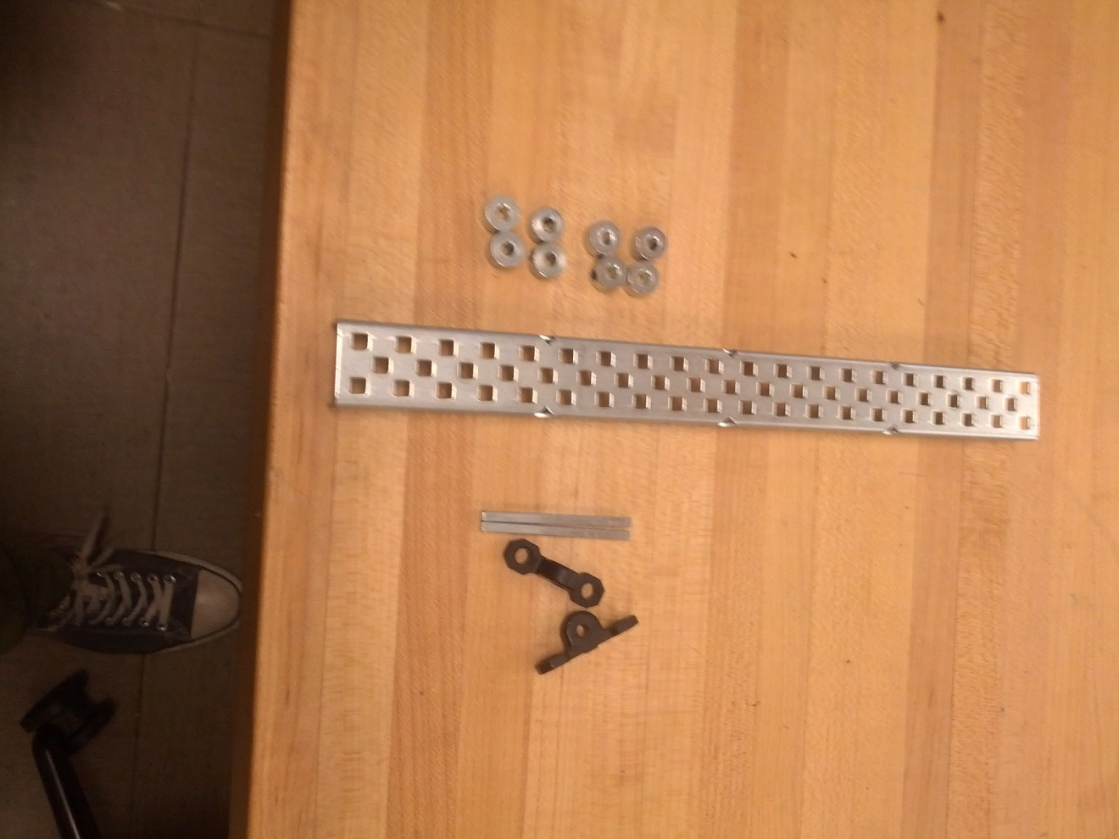

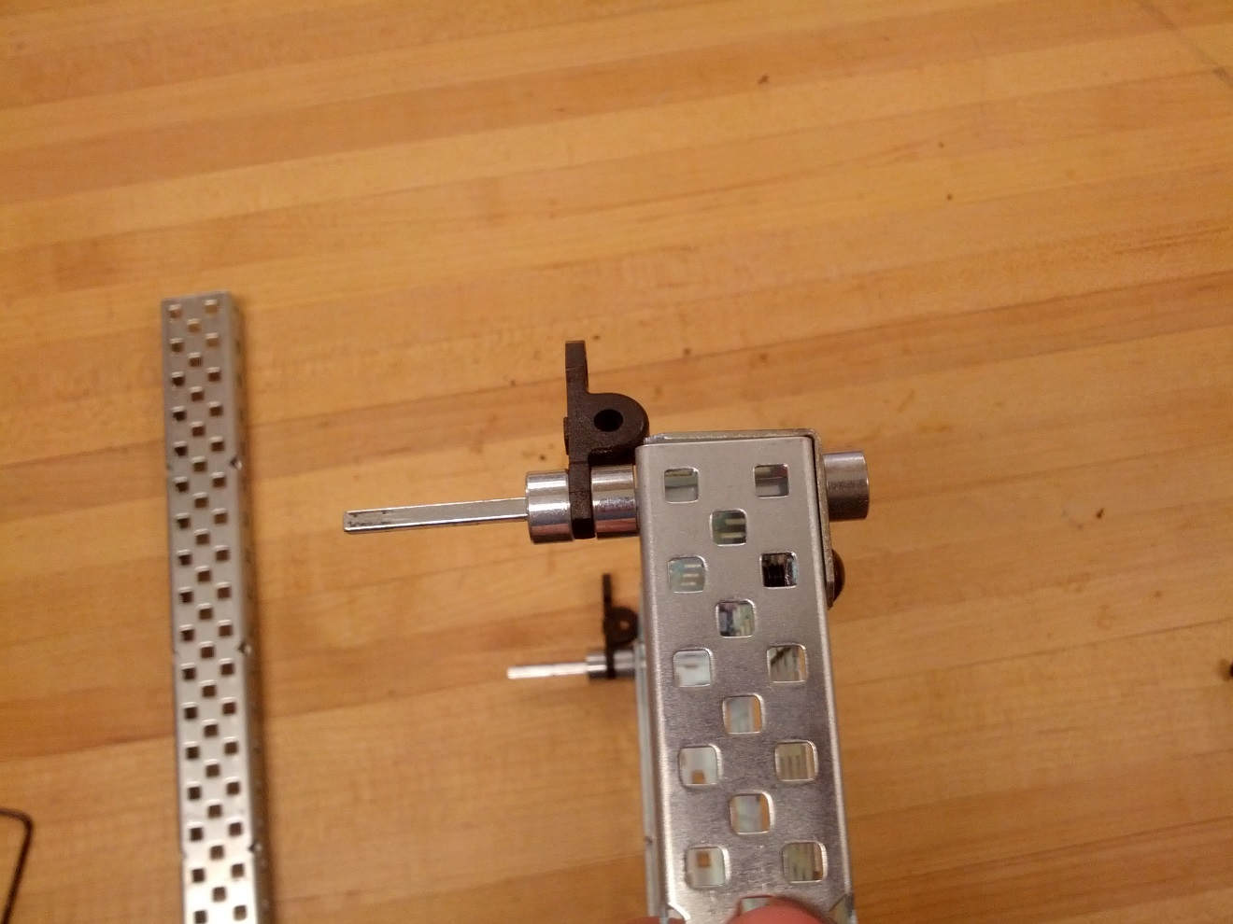

c) Slide rod through other hole in axel connector, affix with cuff, then slide C-beam onto rod, as seen below.

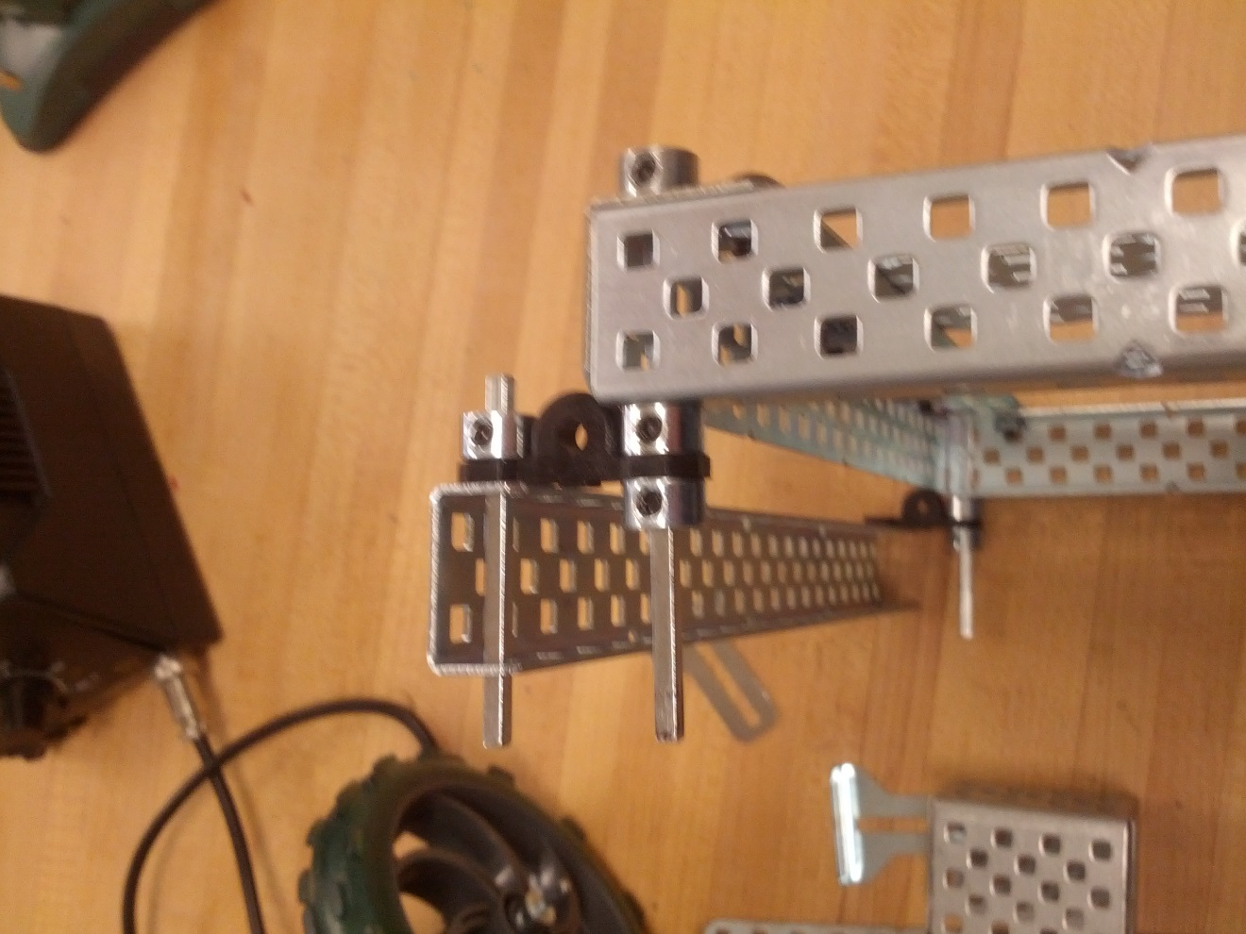

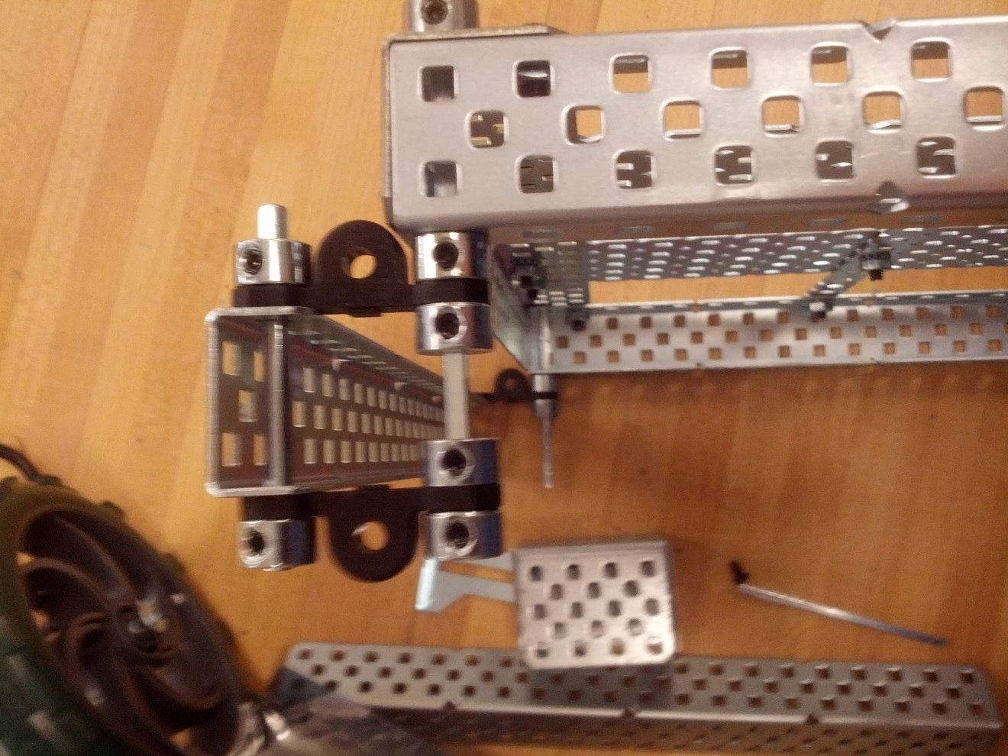

e) Slide cuff onto rod attached to chassis, slide second axel connector onto both rods, fix the end of both rods with cuffs.

f) Repeat for other side

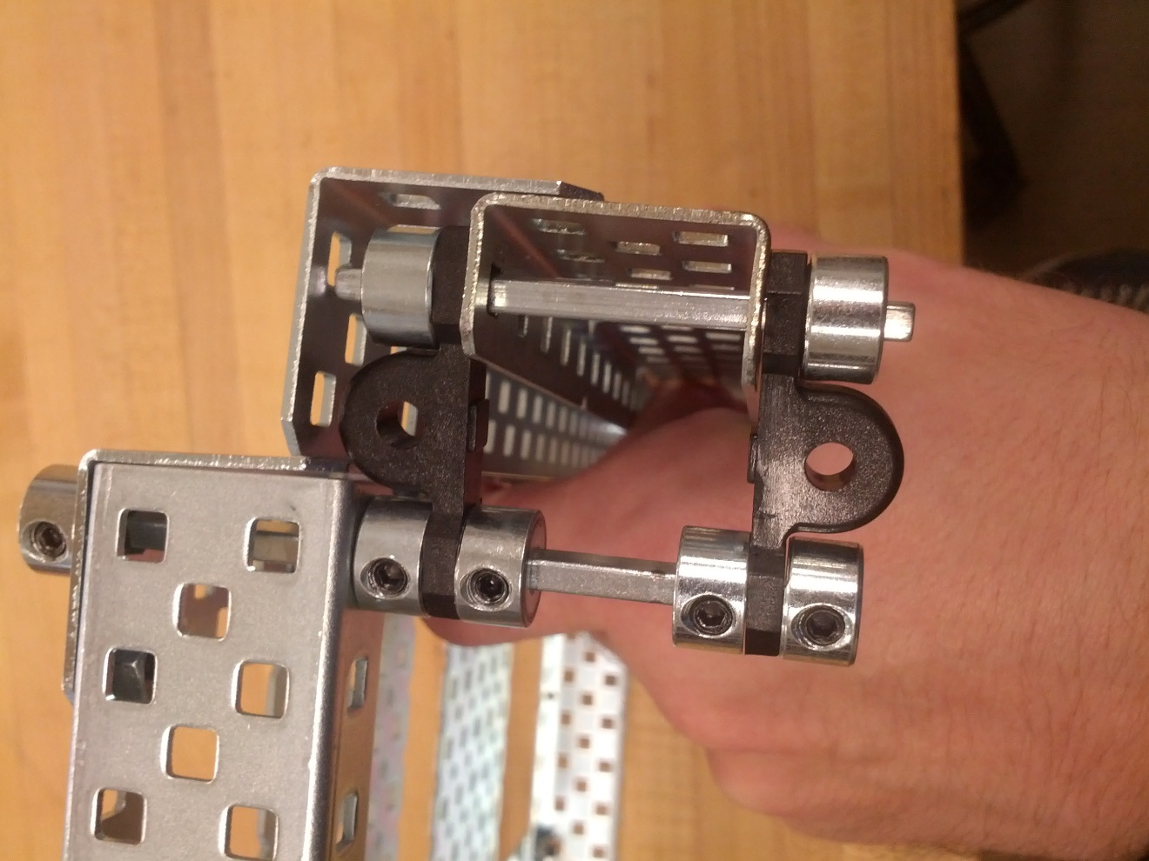

Step 5: Assemble Rack-and-Pinion

Parts Needed:

LENGTH L-Beam

1x Size Bracket

1x Vex Servo

4x SIZE Screws

4x SIZE Nuts

2x SIZE Small Screws

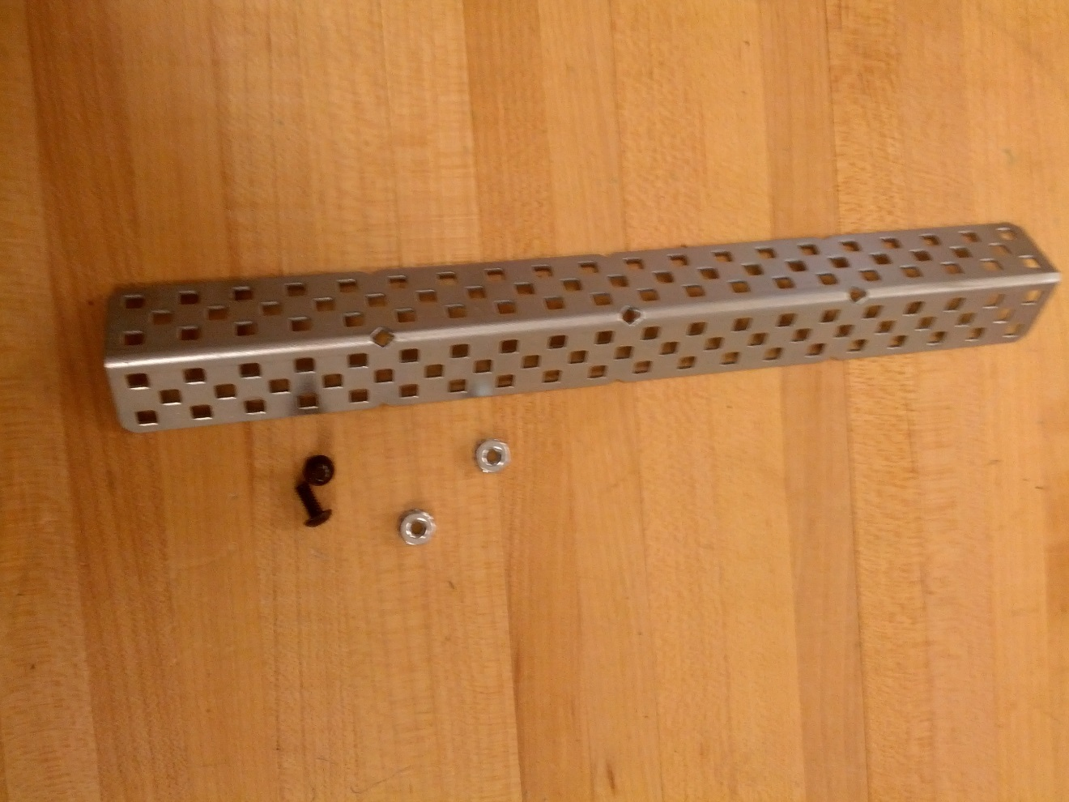

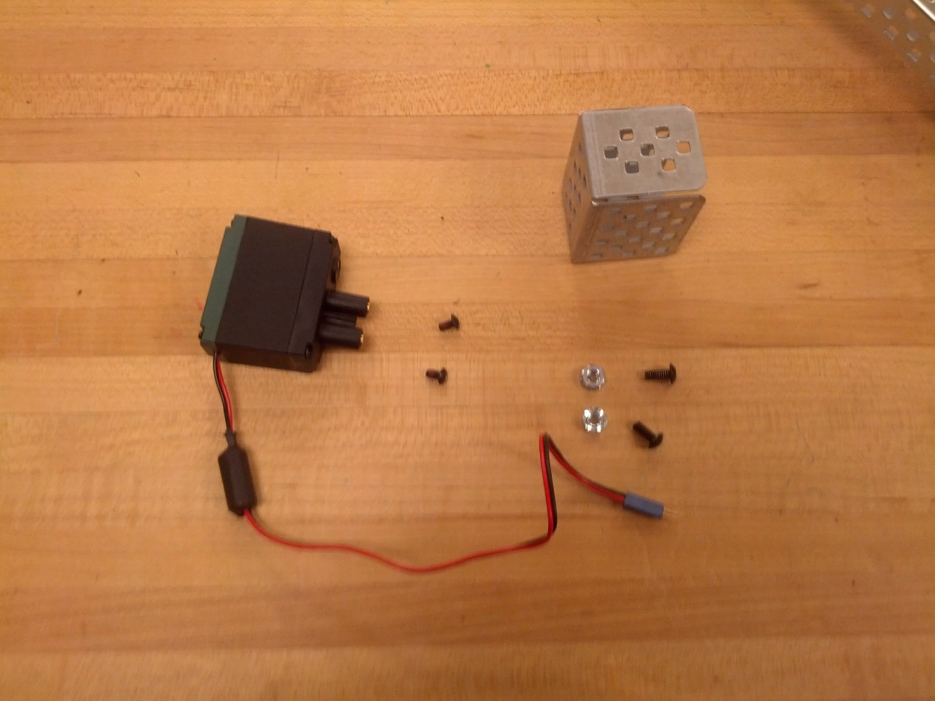

1. Attach L-Beam to top of rack with 2 screws, to provide platform for rack gears

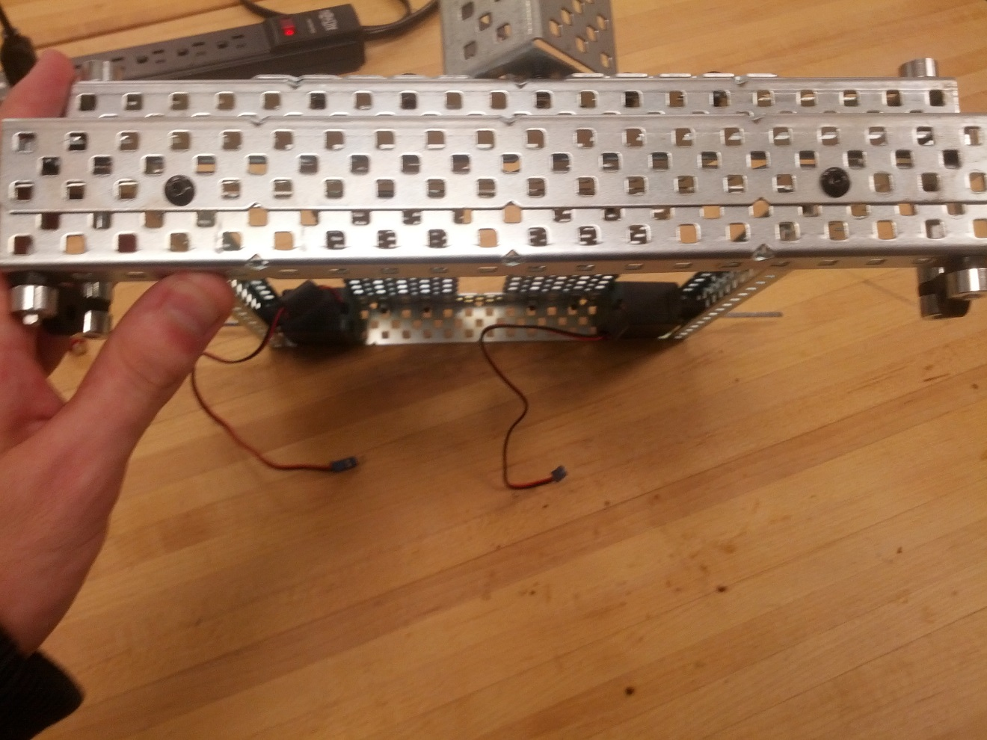

1. Attach bracket to top of chassis, between top plates

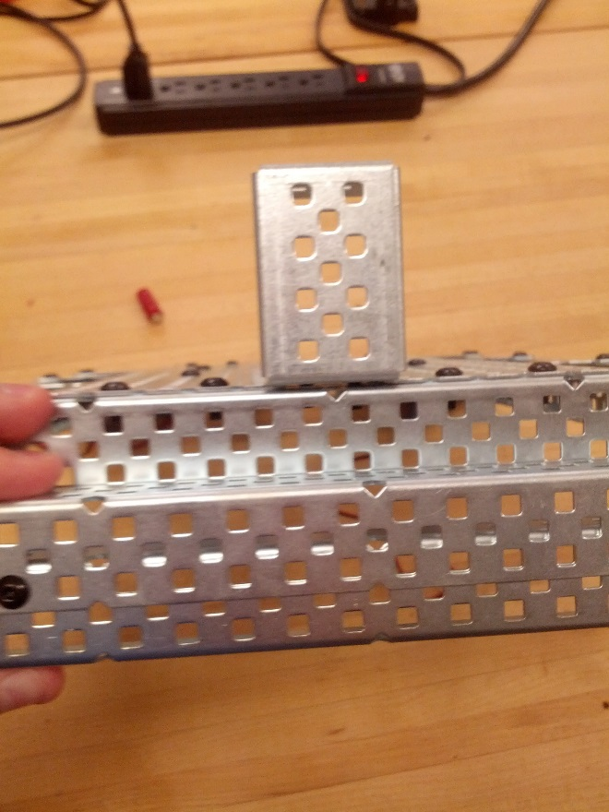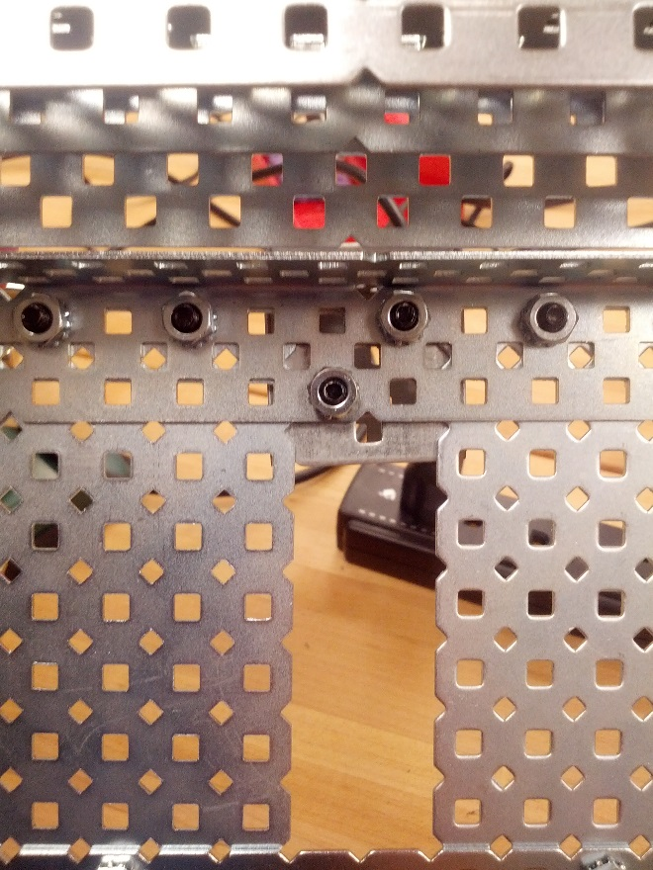

1. Insert servo into bracket, leaving axel hole through bottom center hole

